UID: 504958165

Name: Kanisha Shah

linearRegression.py

* β (Beta) in closed form solution is obtained using:

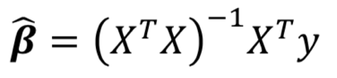

* β (Beta) in Batch Gradient Descent is obtained using:

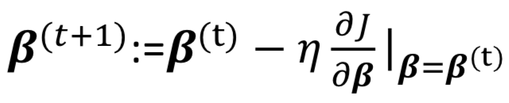

η here is the learning rate and 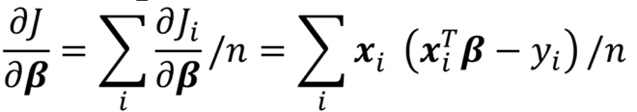

It is calculated until it converges.

* β (Beta) in Stochastic Gradient Descent is obtained using:

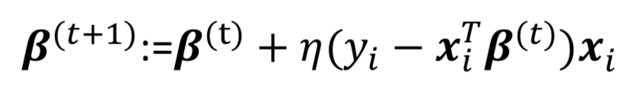

η here is the learning rate.

β is calculated to account for all n data points

logisticRegression.py

* avgLogL was calculated by following formula:



To obtain the average the formula L was divided by n (number of data points).

* Beta in getBeta_BatchGradient was calculated by following formula:

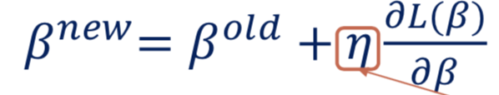

Where partial derivative of L with respect to β is 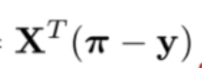 , where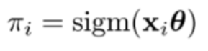

θ here refers to β.

* Beta in getBeta_Newton was calculated by following formula:

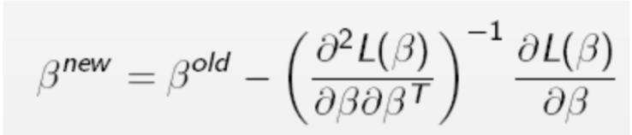

Partial derivative of L with respect to β is calculated as in Batch Gradient.

Second partial derivative of L is  **- (X^T * X) • (sig(X * B) • (1 - sig(X * B)))**.